Title of the contribution

M. Kamislioglu^{1,2}, ...

¹ Affiliation1..., Address, Country
² Affiliation2..., Address, Country

Abstract

- Abstract maximum length: 1 page
- The Abstract can contain figures as indicated below
- Please submit the Abstract as a pdf file

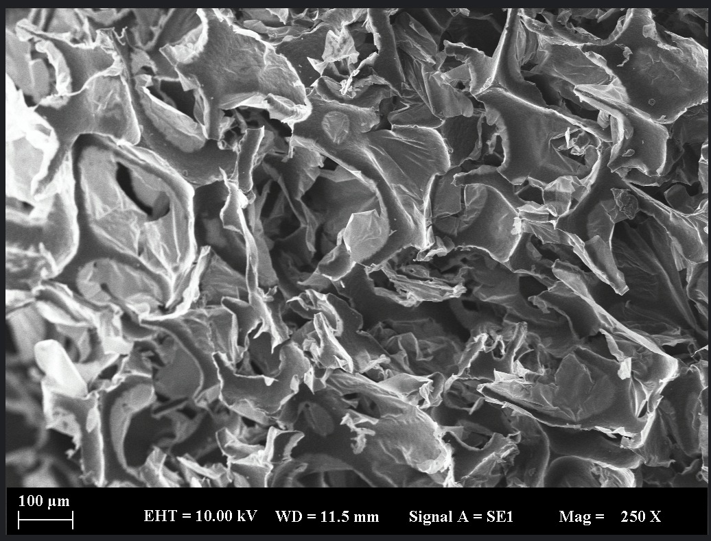
Figure 1. The caption of the figure.

References
1. First reference
2. Second reference

Acknowledgements
The acknowledgements.

